ENTITY RELATIONSHIP DIAGRAM
EXPLANATION REPORT
Complaint Management System
A polished functional explanation of entities, keys, and business relationships
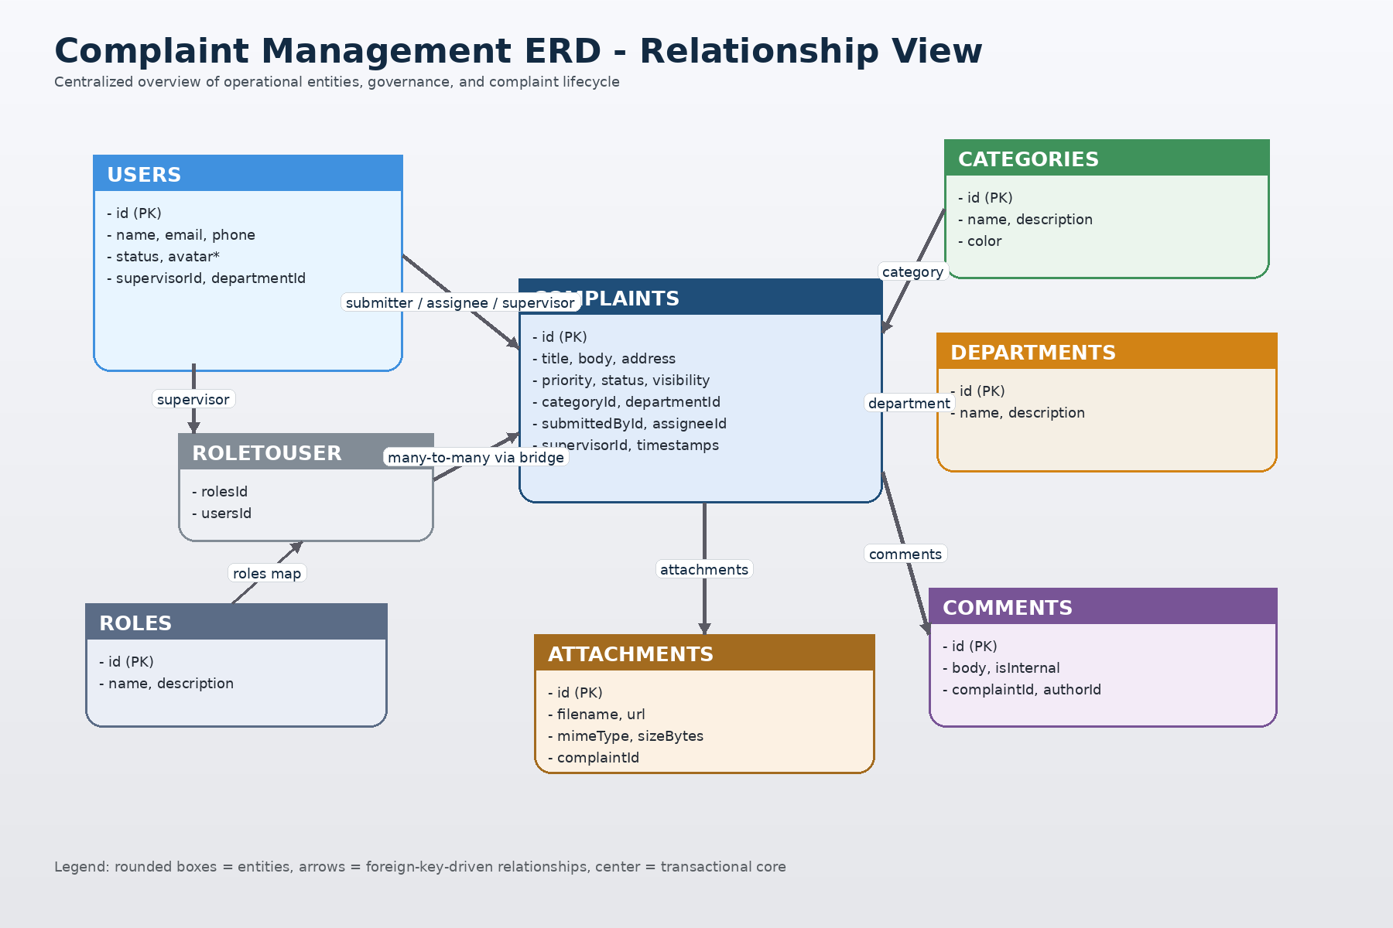
Document Type | Database Architecture Explanation
Main Scope | Users, roles, departments, categories, complaints, comments, attachments, and authorization mapping

1. Executive Overview
This document explains the ERD structure in plain professional English and highlights how the schema supports complaint intake, assignment, supervision, collaboration, and evidence management.
The database is centered around the complaints table, which works as the operational heart of the system. Around this core, the model introduces governance entities such as users, roles, departments, and categories, plus collaboration entities such as comments and attachments. This structure makes the design practical for a municipal or enterprise complaint-handling platform where routing, accountability, and traceability are critical.
Design highlight: the schema balances transactional workflow (complaints), organizational structure (departments and roles), and auditability (comments, timestamps, and attachments).
2. ERD at a Glance
Visual summary of the most important entities and how they connect to the complaint lifecycle.

From | To | Cardinality | Interpretation
users | users | 1 : many | A supervisor can manage many agents through supervisorId.
departments | users | 1 : many | One department can contain many users.
roles | users | many : many | Implemented through RoleToUser.
categories | complaints | 1 : many | Each complaint belongs to one category.
departments | complaints | 1 : many | A department may receive many complaints.
users | complaints | 1 : many | Users participate as submitter, assignee, and supervisor.
complaints | comments | 1 : many | A complaint can have many comments.
users | comments | 1 : many | A user can author many comments.
complaints | attachments | 1 : many | A complaint can have many attachments.
3. Entity-by-Entity Explanation
Each table below is described by purpose, structure, and its role in the complete workflow.
USERS
Business purpose | Stores all platform users including citizens, agents, and supervisors. It also supports managerial hierarchy through self-referencing supervision.
Primary key | id
Foreign keys | supervisorId -> users.id, departmentId -> departments.id
Key notes | A user may submit complaints, be assigned complaints, supervise complaints, write comments, and hold one or more roles. Key fields include: name, email, password, phone, status, avatarInitials, avatarColor, createdAt, updatedAt.
ROLES
Business purpose | Defines access-control roles used by the application, such as admin, agent, or supervisor.
Primary key | id
Foreign keys | No direct foreign keys.
Key notes | Connected to users using a many-to-many bridge table named RoleToUser. Key fields include: name, description, createdAt, updatedAt.
DEPARTMENTS
Business purpose | Represents organizational units responsible for handling complaints.
Primary key | id
Foreign keys | No direct foreign keys.
Key notes | Departments group users and also serve as routing destinations for complaints. Key fields include: name, description, createdAt, updatedAt.
CATEGORIES
Business purpose | Classifies complaints by topic and provides a configurable display color for UI grouping.
Primary key | id
Foreign keys | No direct foreign keys.
Key notes | Each complaint must belong to exactly one category. Key fields include: name, description, color, createdAt, updatedAt.
COMPLAINTS
Business purpose | Acts as the central transactional table that records complaint details, routing, visibility, lifecycle state, and resolution milestones.
Primary key | id
Foreign keys | categoryId -> categories.id, departmentId -> departments.id, submittedById -> users.id, assigneeId -> users.id, supervisorId -> users.id
Key notes | This is the system centerpiece. It connects to category, department, submitter, assignee, supervisor, comments, and attachments. Key fields include: title, body, address, priority, status, visibility, isAnonymous, citizenRating, resolvedAt, closedAt, createdAt, updatedAt.
COMMENTS
Business purpose | Captures discussion, updates, and audit-style notes attached to complaints.
Primary key | id
Foreign keys | complaintId -> complaints.id, authorId -> users.id
Key notes | Supports both public-style commentary and internal notes depending on the isInternal flag. Key fields include: body, isInternal, createdAt, updatedAt.
ATTACHMENTS
Business purpose | Stores file metadata for documents or media attached to a complaint.
Primary key | id
Foreign keys | complaintId -> complaints.id
Key notes | Designed for one-to-many storage where each complaint can have multiple evidence files. Key fields include: filename, url, mimeType, sizeBytes, createdAt.
ROLETOUSER
Business purpose | Bridge table that implements the many-to-many relationship between users and roles.
Primary key | Composite: rolesId + usersId
Foreign keys | rolesId -> roles.id, usersId -> users.id
Key notes | Keeps authorization flexible and scalable because one user can hold several roles. Key fields include: rolesId, usersId.
4. Enumerations and Controlled Values
The schema uses enums to keep workflow logic and visibility rules consistent across records.
Enumeration | Allowed Values
Priority | low, medium, high, critical
Status | open, in_review, assigned, in_progress, resolved, rejected, escalated, closed
UserStatus | active, inactive, pending
ComplaintVisibility | public, private
5. Functional Reading of the Model
How the database behaves from a business-process perspective.
• A citizen or registered user creates a complaint, and that record becomes the main case file in the system.
• The complaint is classified by category, optionally routed to a department, and can be assigned to a responsible staff member.
• Users participate in different operational roles: submitter, assignee, supervisor, and comment author.
• Comments provide communication history, while attachments preserve supporting evidence and external files.
• Status, priority, visibility, timestamps, and rating fields give the model enough control for lifecycle tracking and reporting.
Architectural observation: complaint assignment and supervision are both modeled through foreign keys back to users. This is efficient, but it also means application logic should clearly distinguish the responsibilities of each user reference.
6. Final Assessment
Summary interpretation of the ERD quality and readiness.
Overall, this ERD is well structured for a complaint-management product. It demonstrates clear separation of concerns, strong relational integrity, and enough flexibility to support routing, ownership, escalation, internal collaboration, and evidence tracking. The only implementation detail that should be watched carefully is role clarity in the application layer, especially where one user can appear in multiple capacities inside the same complaint record.
In presentation terms, the design is centered, readable, and business-oriented: the schema tells a clear story from complaint submission to case closure. That makes it suitable not only for development, but also for stakeholder explanation, system documentation, and database review sessions.

